MDP Metal Detector
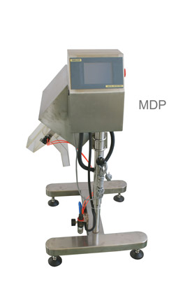

Product specifications
- Model: MDP
- Theory: Balance Coil.
- Sensor adjustment:Self-study and manual adjustment.
- The standard diameter: 100 * 40 (mm).
- Alarm:Buzzer & Lamp (optional).
- Reject system:Rapid isolation shield.
- Power:AC110V/220V 50-60HZ.
- Rated Output: Appr 200W.
- Dimension:700mm (L) * 760mm (W) * 1200 ± 10mm (H).
- Weight:Appr 88Kg.

FEATURES
- Suitable for high speed drug particles testing.
- Consistent with the pharmaceutical industry hygiene requirements with high-performance tablet 3,Tablet press, capsule filling machine combines.
- Man-Machine Interface, User-friendly operation
- Can be set to 100 species.
- Automatically or manually adjust the sensitivity.
- Automatic learning function, compensation of the "product effect"
- 1000 records.
- Record data printing.
- A special rejection device designed for powdery and granular bulk materials.
- Excluding metal impurities, ensuring the production line working well.
- Adjustable for height and angle to facilitate the production line installation.
- high-speed cylinder control, fast response.

