MDF Metal Detector

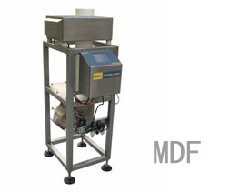

SPECIFICATION
- Model: MDF
- Detection method: balanced coil.
- Sensitive adjustment: automatic or manual.
- Standard tube size: ￠120mm.
- Alarm mode: buzzer and lamp (optional).
- Reject method: Quick flap system.
- Power: AC110V/220V 50-60HZ.
- Power: 200W.
- Dimensions: 420mm(L)*500mm(W)*1300±10mm(H).
- Weight: Appr. 88kg

FEATURES
- Stainless Steel Conveyor with high waterproof level design.
- 100 Product Preset; Easy to shift or edit.
- 2000 logs memory, easy to look up and print out.
- Based on friendly touch screen operation.
- High speed metal detection unit.
- Multi-function operation system and multi-language for option.
- Advanced product’s effective learn.
- Variety of peripheral system connection and setup.
- Detection frequency optional.(Factory preset).
- Special reject system design, suitable for powder and granular bulk materials.

