MDC-Symmetric

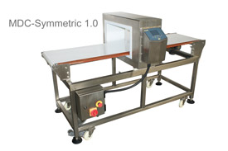
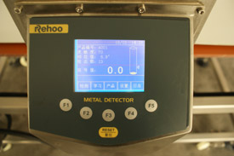

FEATURES
- Based on High speed CPU control circuit, 320x240 resolution monochrome graphic LCD display, white text on a blue background
- Compact design with unique front cover and panel
- Adapt to touchpad integrated with key operation, Simple and durable
- Full-digital signal processing, high-precision measurement of signal
- Synchro Phase Angle adjustment
- Multi-stage signal stability circuit
- Automatic "self-teaching" function, compensating for product effect variations
- 20 kinds products memory, 1000 detection logs.
- Single-mode rejection time adjustment
- Adapt to worldwide voltages
- Protection grade IP65 (optional)

SPECIFICATIONS
- Theory: Balanced Coil
- Aperture Size:50mm×150mm
- Belt Speed:10-36m/min
- Reject System: Air blast/Arm Pusher/Swing Arm(option)
- Alarm: Buzzer&Lamp
- Power:AC110V/220V 50-60HZ
- Rated Output:120W
- Dimension：1850mm（L）×756mm（W）×985mm（H）±20mm
- Weight: Appr.140KG

