MDC-D Metal Detector
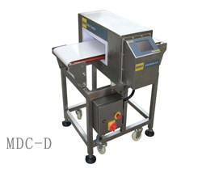

FEATURES
- Based on High speed 32bit CPU control circuit.
- LCD with Touch Screen, Easy to operation.
- Multi-Functional OS and dual-language.
- DSP Technology and digital signal filter.
- 100 products memory.
- 1000 detection logs.
- Multiple setup for peripheral connectiion.
- Frequency optional.
- Printer connection and signal analyze software.
- Separated DSP module and control unit.
- Automatical rejection module.
- Multi-functional stainless steel frame.

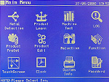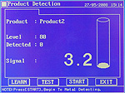

REJECTOR
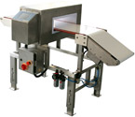Falling Drop
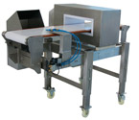Air Jet
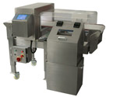Air Pusher

PURPOSE
- Designed for food industrial and Pharmaceutical industrial use.
- Also can fit for detecting the chemical products, rubber products.

SPECIFICATIONS
- Theory： Balanced Coil
- Adjustment：Auto and Manual
- Alarm：Buzzer & Lamp
- Conveyor Speed：18-32m/min
- Power：AC110V/220V 50-60HZ
- Rated output：Appr.200W

