MDC-B Metal Detector
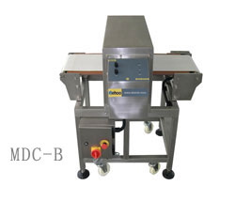

FEATURES
- Automatic adaptable for product effect.High attributes of products can be detected.
- All-digital signal processing and transmission technology , high sensitivity, excellent reliability.
- Based on 32bit high speed CPU.
- Double LED line indicate the realtime Ferrous and Non-Ferrous sensitivity exactly.
- Ferrous and Non-Ferrous level dividual adjustment.
- Optional rejict systems.
- High protection degree and height djustable frame.

PURPOSE
- Online metal detection for food product.A step for food safety(HACCP required)
- Also can fit for detecting the chemical products, rubber products.

SPECIFICATIONS
- Theory: Balanced Coil
- Adjustment: Auto and Ferrous and Non-Ferrous level dividual adjustment
- Aperture Size: 600*80mm
- Alarm: Buzzer & Lamp
- Reject system: Air blast/air pusher/swing arm(option)
- Belt Speed:25-32m/min(Adjustment)
- Power:AC110V/220V 50-60HZ
- Rated Output: Appr140W
- Dimension:1620mm(L)*1000mm(W)*1100mm±50mm(H)
- Weight:Appr200Kg

