CWC-450NS Check Weigher

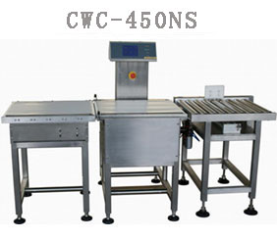

FEATURES
- Strong stainless steel structure; Water proof design.
- High accurate loadcell; Based on advanced DSP technology.
- Automatic weighing compensation and zero tracking.
- 100 products preset; easy to edit and recall.
- Quickly product shift and speed recall.
- 2000 sorting records; Printer output ready.
- Touch screen; friendly operation interface.
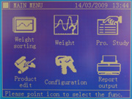Control Panel
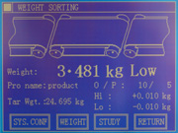Control Panel

REJECTOR
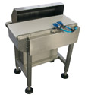Air Jet
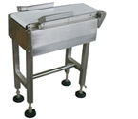Flipper Type
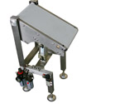Falling Drop

PURPOSE
- Online weight check for packed food. Step for food quality control.

SPECIFICATIONS
- Measurement: Strain Guage
- Regection: Pusher with roller conveyor
- Operation: Touch Screen
- Alarm: Buzzzer & Lamp
- Belt speed: 45m/min
- Power Supply: AC110V/220V 50-60Hz
- Rated Output: Appr.200W
- Dimension: 1300mm(L)* 800mm(W)* 1200±100mm(H)
- Weight: Appr.90kg

